Algebra 1: Unit 12, Lesson 3

- The box plot displays the number of runs scored against different pitchers for a minor league baseball team in the 2021 regular season.
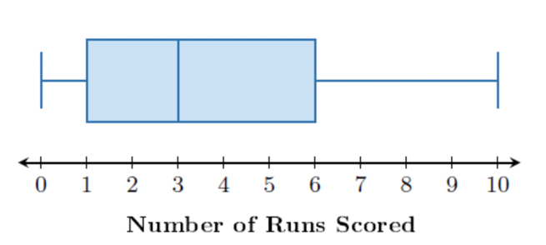
What is the median of the data set?
$$3$$

- The histogram shows the height, in inches (in), of a group of male students on the basketball team at Choctawhatchee High School.
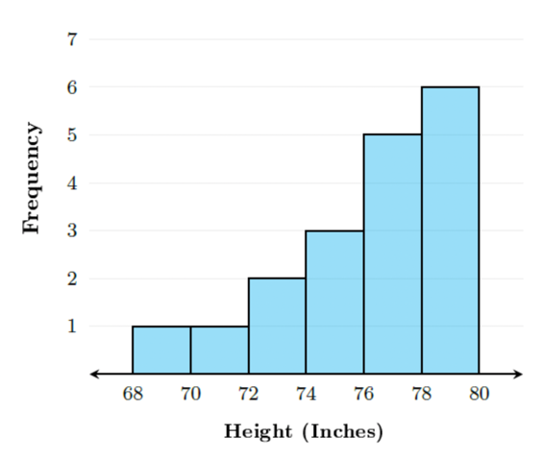
What is the shape of the distribution?
Left skewed

- The box plot displays the number of runs scored against different pitchers for a minor league baseball team in the 2021 regular season.
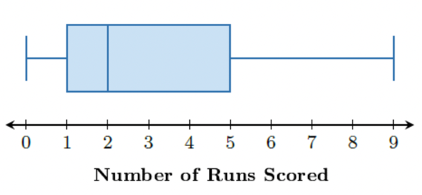
Which is the Interquartile Range (IQR) of the data set?
$$4$$

